Program 15
Design a registration form in HTML, and do necessary server side validations using PHP.

vali.php:
<!DOCTYPE html>
<html>
<head>
<title>Form Validation</title>
<style>
body {
background: #eef2f3;
font-family: Arial, sans-serif;
}
.container {
width: 380px;
margin: 60px auto;
padding: 25px;
background: #ffffff;
border-radius: 10px;
box-shadow: 0px 0px 12px rgba(0, 0, 0, 0.15);
}
h3 {
text-align: center;
color: #2c3e50;
margin-bottom: 20px;
}
label {
font-weight: bold;
color: #34495e;
}
input[type="text"], input[type="password"] {
width: 95%;
padding: 10px;
margin: 6px 0 14px 0;
border: 1px solid #bfbfbf;
border-radius: 5px;
font-size: 15px;
}
input[type="submit"] {
width: 100%;
background-color: #3498db;
color: white;
border: none;
padding: 12px;
font-size: 16px;
font-weight: bold;
border-radius: 6px;
cursor: pointer;
}
input[type="submit"]:hover {
background-color: #2980b9;
}
.error {
color: #e74c3c;
margin: 10px 0;
font-size: 14px;
background: #fdecea;
padding: 8px;
border-radius: 5px;
}
.success {
color: #27ae60;
font-size: 15px;
margin: 15px 0;
padding: 8px;
background: #e7f7ec;
border-radius: 5px;
}
</style>
</head>
<body>
<div class="container">
<h3>Form Validation</h3>
<form method="post" action="">
<label>Name :</label><br>
<input type="text" name="name"><br>
<label>Email :</label><br>
<input type="text" name="email"><br>
<label>Phone :</label><br>
<input type="text" name="phno"><br>

<label>Password :</label><br>
<input type="text" name="password"><br>
<input type="submit" name="submit" value="Submit">
</form>

<?php
if (isset($_POST['submit'])) {
$name = $_POST['name'] ?? "";
$email = $_POST['email'] ?? "";
$phno = $_POST['phno'] ?? "";
$password = $_POST['password'] ?? "";

if (empty($name)) {
echo "<div class='error'>Name field cannot be empty!</div>";
}
else if (empty($email)) {
echo "<div class='error'>Email field cannot be empty!</div>";
}
else if (!filter_var($email, FILTER_VALIDATE_EMAIL)) {
echo "<div class='error'>Invalid email format (Use: example@domain.com)</div>";
}
else if (empty($phno)) {
echo "<div class='error'>Phone number cannot be empty!</div>";
}
else if (!ctype_digit($phno) || strlen($phno) != 10) {
echo "<div class='error'>Phone number must be exactly 10 digits!</div>";
}
else if (empty($password)) {
echo "<div class='error'>Password cannot be empty!</div>";
}
else if (!preg_match('/^(?=.*[a-z])(?=.*[A-Z])(?=.*\d).{8,}$/', $password)) {
echo "<div class='error'>Password must have 8+ chars, 1 uppercase, 1 lowercase, 1 number.</div>";
}
else {
echo "<div class='success'><b>Form Submitted Successfully!</b></div>";
echo "<div class='success'>
Name: $name <br>
Email: $email <br>
Phone: $phno <br>
</div>";
}
}
?>
</div>
</body>
</html>
OUTPUT:
Form:
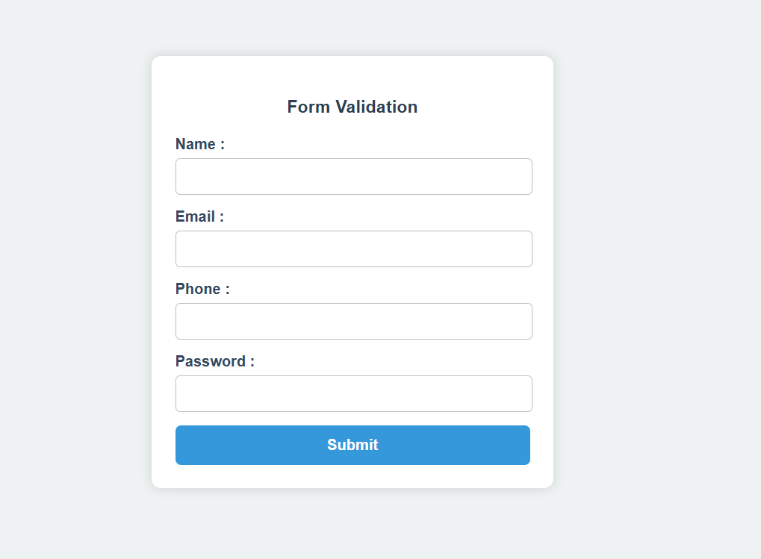
Name validation:
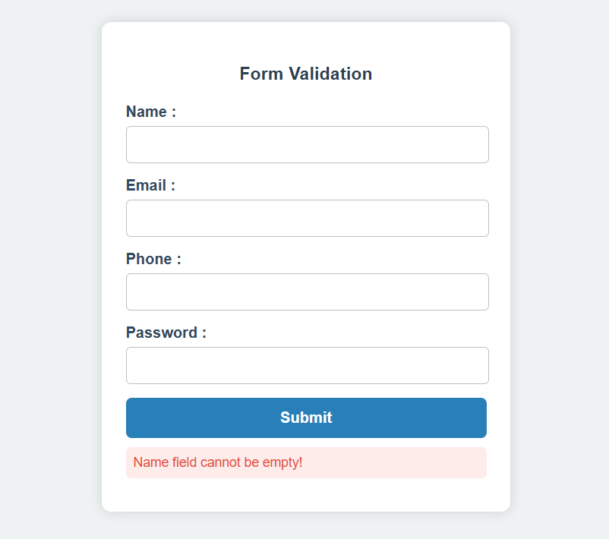

Email validation:
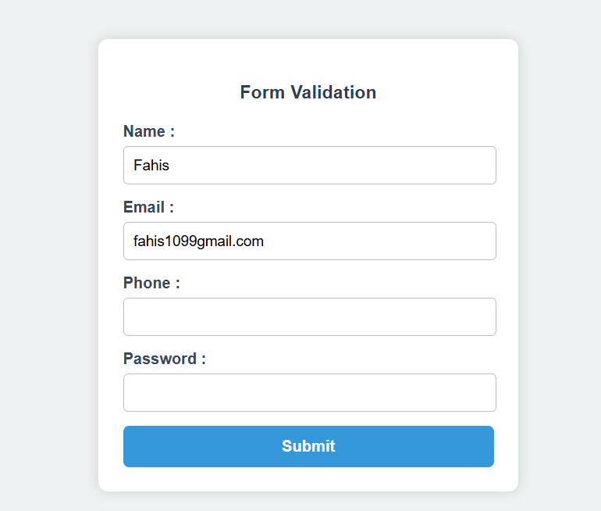
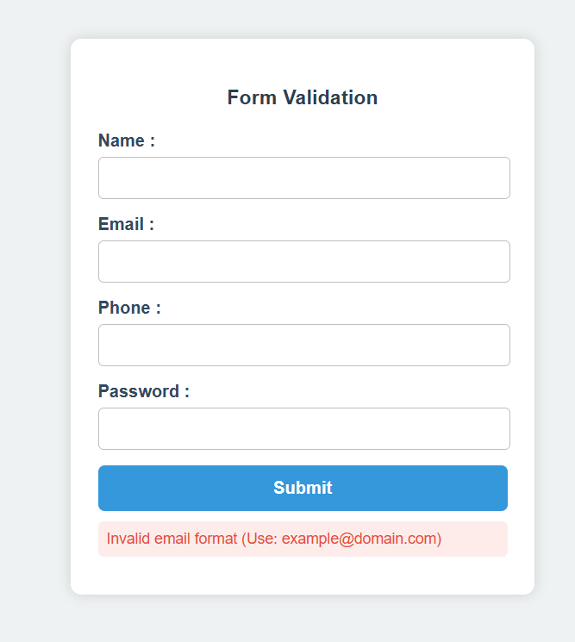

Phone validation:
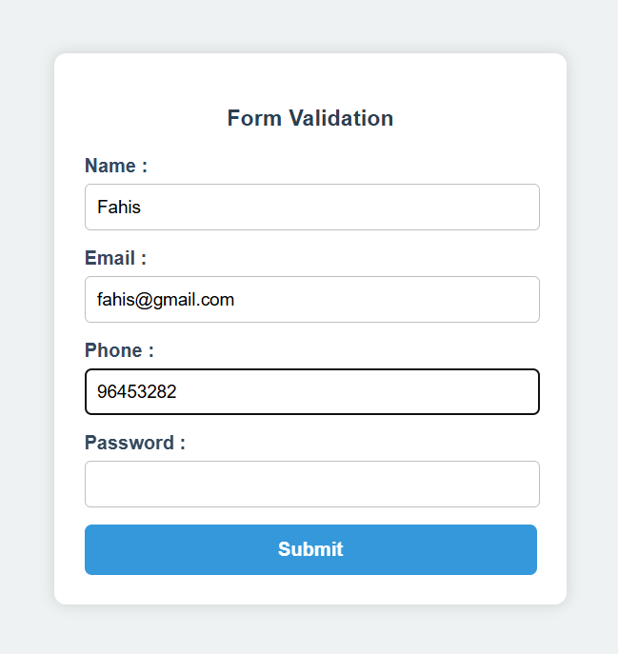
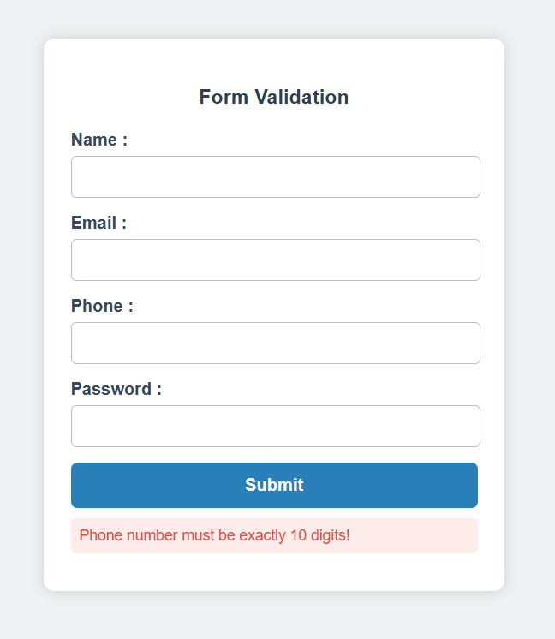

Password validation:
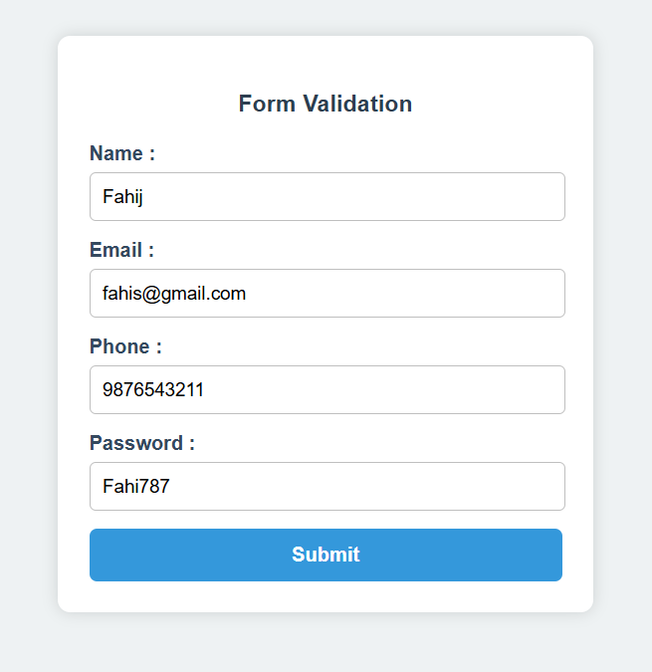

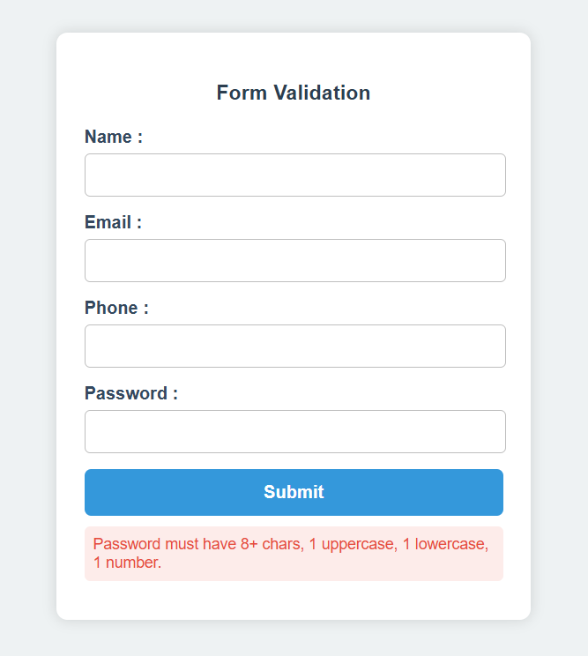
Successful:
